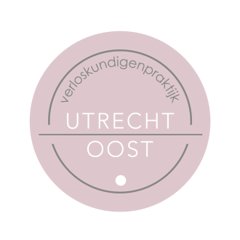

Frequently asked questions about pregnancy and COVID-19

I work in a hospital or other care institution (in an intramural care context). Can I continue to work throughout my entire pregnancy?
Up to 28 weeks of pregnancy, you can continue to perform your normal work activities, including caring for people with COVID-19. Obviously, you must follow the applicable protocols and measures for personal protection (for example by using a face mask that covers your mouth and nose). From 28 weeks on, it is not recommended to continue providing care related to COVID-19. However, you can continue to do replacement work; if necessary, you can consult the company doctor about this.

I work in healthcare, but not in a hospital or other care institution. (I work in extramural care for example, as GP or district nurse). Can I continue to work throughout my entire pregnancy?
Up to 28 weeks of pregnancy, you can continue to perform your normal work activities, including caring for people with COVID-19. Obviously, you must follow the applicable protocols and measures for personal protection (for example by using a face mask that covers your mouth and nose). From 28 weeks on, you are no longer permitted to continue providing care related to COVID-19. In addition, you must be able to keep a distance of 1.5 metres from others during your work. If this is not possible, you should be offered suitable alternative work; if necessary, you can consult the company doctor about this.

I am pregnant and work at a childcare facility, school or after-school childcare centre. Can I continue to work throughout my entire pregnancy?
In principle, you can continue working up to 28 weeks of pregnancy. Of course, the national measures and hygiene recommendations still apply in this context. If you cannot keep 1.5 metres away from others (colleagues, parents/carers and children*) during your work, then it is advisable from 28 weeks of pregnancy to do replacement work that will allow you to maintain distance. If necessary, you can consult the company doctor about this.
*This does not apply if you work with children up to the age of 4.

I work in some other profession. Can I continue to work throughout my entire pregnancy?
In principle, you can continue working up to 28 weeks of pregnancy. Of course, the national measures and hygiene recommendations still apply in this context. If you cannot keep 1.5 metres away from others (colleagues or customers) during your work, then it is advisable from 28 weeks of pregnancy to do replacement work that will allow you to maintain distance. If necessary, you can consult the company doctor about this.

